DMX Module Settings
Every module in DotNetNuke has a Settings page which can be found through the module’s menu:
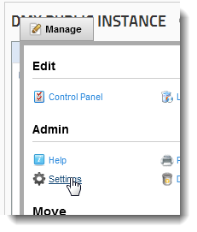
This takes you to a configuration page where you’ll see a tab for specific Document Exchange settings. Here you get the option to set specific parameters that only pertain to this module’s instance. So whatever you change here does not influence any other DMX module anywhere.
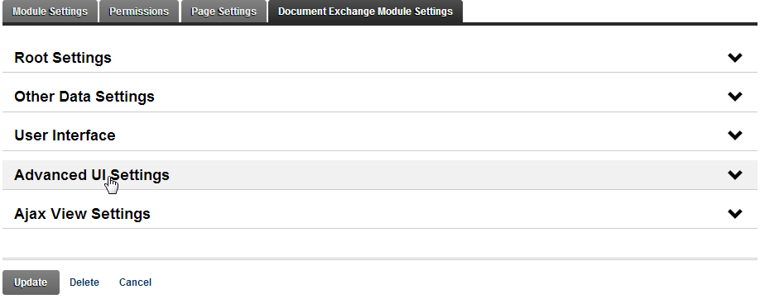

Root Settings
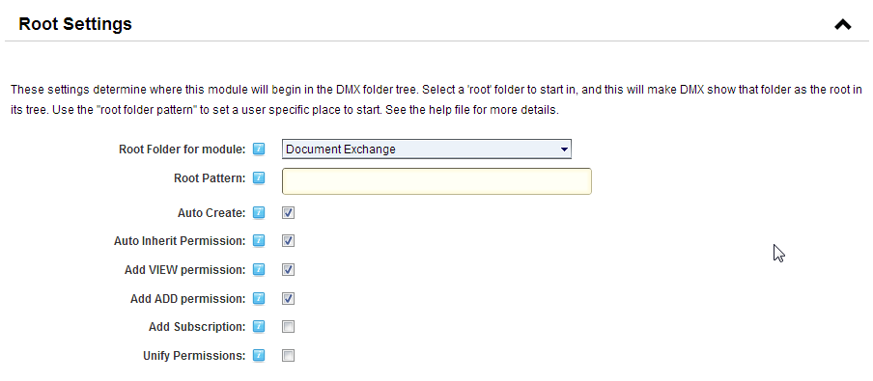
Underlying every instance of DMX within a single portal is a single document tree (see also “Getting Started” manual). Every DMX instance is a window to this tree, or put differently, a virtual drive starting at some point in this tree. By default this is set to the ‘absolute root’ of the underlying tree. In the dropdown shown, you’ll see a list of all the folders in the portal. Set it to any folder to start the document tree there.
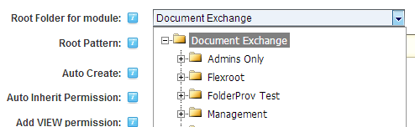
NOTE: this setting only affects the document tree that is shown in the module and not the categories, search, or subscriptions content that is shown. I.e. when a user performs a search, the whole document tree is searched. Similarly, when a user selects a category all content from that category is shown. All content shown is always subject to the current user’s security status.

Root Pattern
You can define a pattern to add to the root folder where the module should start. This pattern can include tokens. Tokens are a DNN standard way of injecting information about the environment at runtime, such as details about the user. [User:DisplayName] for instance will return the user’s displayname. The root pattern can include such a token. So specifying a pattern ‘[User:Username]’ (note this is not case-sensitive) here would make the root for user ‘admin’ start at ‘Start/admin’. Note you can also use subfolders here. So setting it to ‘[User:Username]/Documents’ would start the module at ‘Start/admin/Documents’ for user admin.
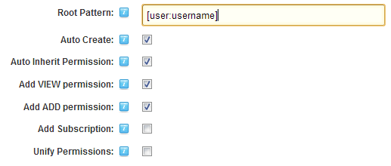

Auto Create
This will create the folder (including any parent folders) automatically when the user loads the page. Note: permissions will be inherited from the parent! So if you set all users to have access to ‘Start’ in this case (the base folder chosen as root folder) then the auto created subfolders will also be visible to All Users.

Auto Inherit Permission
Selecting this will copy the parent folder’s permissions to the newly created folder. If you don’t select this the permissions will only include access for document administrators. So if you need some role to manage the content of all the created subfolders then you need to set that role to have the proper access to the parent folder and then select this option.

Add VIEW permission
Make sure the current user has view permission on the folder. If not, add the user to those with VIEW permissions.

Add ADD permission
The same as above, but then for ADD permission. This will make sure the active user can add content at this location.

Add Subscription
Subscribe the user to this folder automatically. This means the user will get notifications of any activity in this folder.

Unify Permissions
This option makes sense if you expect that the user’s folder may already be there before he/she arrives and hence before the permissions specified above have been applied. The application of permissions only happens on the folder that is the new root. If content was already there, their permissions remain unaffected. By selecting this option you tell DMX to promulgate the new permissions to all the existing content once the user arrives.

Making user-based private folders
Using the above you can tune DMX to have private folders for users quite easily. The root folder must have view/edit/add permissions restricted to let’s say administrators only. Then you specify the root pattern to be ‘[User:Username]’ (note: it would be unsafe to use DisplayName as the user can change this him/herself and potentially see someone else’s folder). Finally leave all checkboxes checked so the folder is created and the user can see and add content there.

Making Group-Based Folders
Social Groups were introduced in DNN 6.2. These are a special kind of security roles meant for users to be able to be grouped together to enhance social interaction. DMX supports the concept of group-based folders just like user-based folders mentioned above. The idea is that users can use DMX to share documents in such a group. To accomplish this you set the folder pattern to ‘[group:name]’. DMX will create the folder if it doesn’t exist yet and add permission for the group to view content and add content based on the checkboxes you’ve set. If the visiting user belongs to the group, they will be able to see and add content.
Note: the social groups implementation of DNN relies on the use of the querystring. The querystring will contain the identifier of the group as “GroupId” parameter. DMX picks this up. But care has been taken so that users with malicious intent cannot simply change the GroupId to another value and gain access to folders they don’t have a right to. Users will be shown a red error message that they’ve been denied access if they are not part of the group. If you wish others to be able to see the content, you need to edit the folder and give those users view access (by for instance setting view permissions to Registered Users).
Finally, the consequence of having things driven by the querystring, means that a number of prebuilt templates in DMX will not work properly as they also use the querystring and will not propagate the groupid (unless you edit this in). For this reason there is a new template called “FileDownloadList” which renders a simple list of the files in the group folder and only allows downloading of items. This is a very minimal but effective way to show a file list on a group page. You can add a LetterBox extension (available through the Bring2mind site) to add a kind of upload/dropbox type function so users can add files.

Other Data Settings
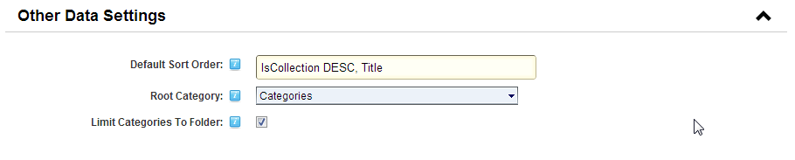

Default Sort Order
Specify the default sort order to use. This is used in both the Ajax and Template UI. The basic (default) sort is ‘IsCollection DESC, Title’. This will put folders at the top and sort alphabetically on title.

Root Category
Like the folder tree, you can tell DMX to start loading the category tree from a particular point. Note this also affects the category tree from which users can select when editing an entry in this module’s instance. It is a way of chunking the category tree across your portal if you need to do this.

Limit Categories to Folder
If you specify both a root folder and a root category you may need to tell DMX that it shouldn’t show documents outside the root folder under the categories that it displays.

User Interface
Document Exchange is designed to be extensible and flexible in many areas. One such area is the UI. It can be told to load different controls to render its content much in the same way as DNN choses to render one module or another. This allows us to offer you more flexibility and also allows us to develop custom solutions based on DMX. The settings below manage what the current module instance renders as UI.
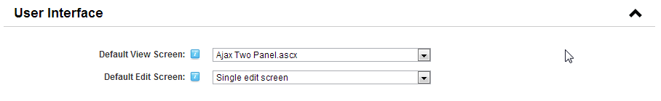

Default View Screen
This setting defines which (view) UI is used for this DMX instance. The default is ‘Ajax UI (2 Panel)’ which is the so-called Ajax UI with two panels (folder tree and file list). The alternatives are a 3 panel Ajax UI which adds a details panel below the file list and a template view which uses HTML templates to render the content. For more information about the latter see the corresponding manual in the help menu of the module.
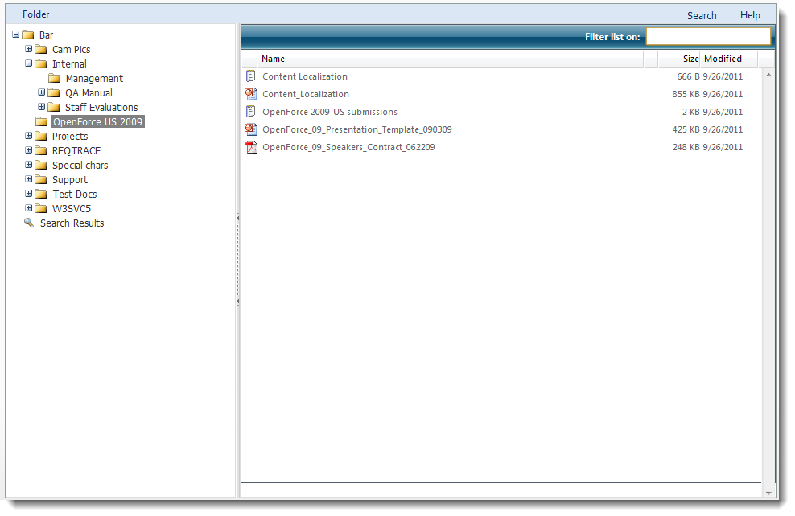
Figure 1. Regular 2 panel Ajax UI
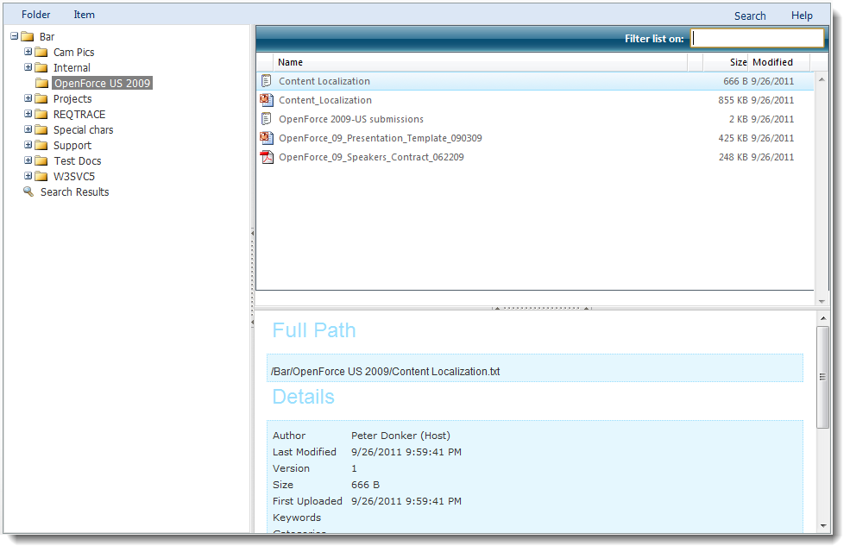
Figure 2. 3 panel Ajax UI
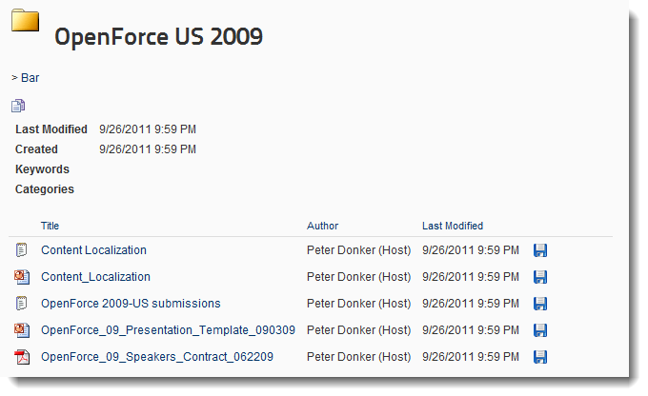
Figure 3. Example of a template UI

Default Edit Screen
DMX is designed to allow the switching of some of the main screens in the application. This includes the edit screen. There are 2 edit screens. The default is an edit screen where users see all the data in one go. The alternative is a wizard type entry of data where the user is walked through various steps to enter the data. You select the screen in the Module’s Settings.
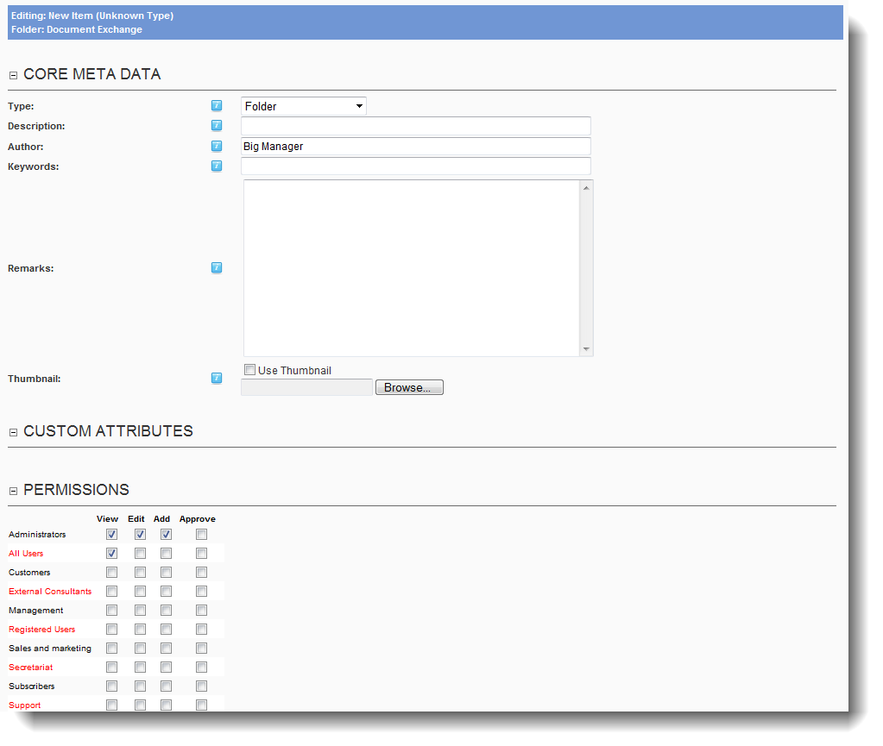
Figure 4. Single edit screen
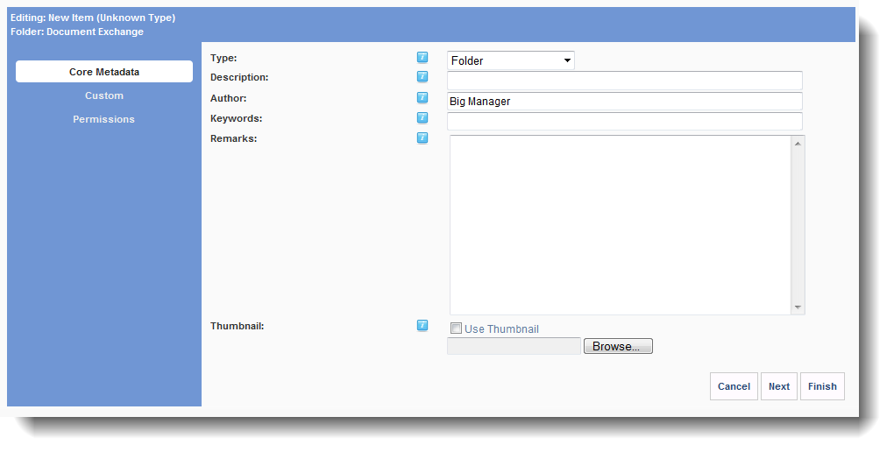
Figure 5. Wizard edit screen

Advanced UI Settings
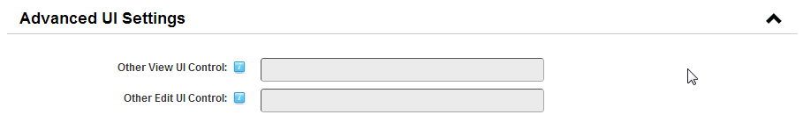
Normally you’ll not want to use this. This can be leveraged in custom applications to provide other UIs that are not listed in the default list. The textboxes only become available when the option “Other” is used in the previous section.

Specific View Settings
Since DMX 6.1 each View UI can have its own settings panel. This is loaded in the last segment of the module settings.

Ajax View Settings
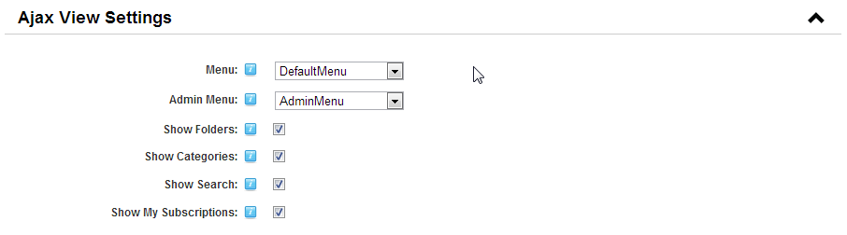

Menu
You can change the main and admin menus for this module instance the main menu is shown on the left and is sensitive to the context (i.e. what is clicked. The admin menu is on the right and is only loaded upon page refresh. The default menus are copied to the portal home directory under ‘DMX\Menu’. So for portal 0 this would be ‘Portals\0\DMX\Menu\DefaultMenu.resources’. This is an XSL file that operates on the XML being generated by the module when making the menu. The XML can be seen if you put the installation into Debug mode (see Main Options) under DMX\Temp\LastRequestedMenu.Xml. If you edit the default menu and the module fails due to errors in it, you can reset it by clicking ‘reset menus’ on the main page of DMX when logged in as Admin:
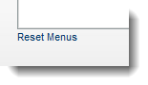
Use this as well after upgrades of DMX to load the latest menu and import any changes to the menu into your portal.

Show Folders/Categories/Search/My Subscriptions
You can hide specific parts of the tree that is shown in the module (left-hand side). By default a document tree is shown, categories, subscriptions, and the last search. You can limit what a user sees here. Obviously if you deselect everything, your users will not be able to use DMX as there will be nothing in the tree on the left.

Template View Settings
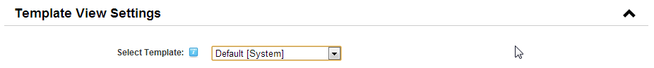
If you opted to display DMX in templated view, you can choose the template to use here. See the template manual for more details on editing and creating your own templates.

Settings for Search Screen
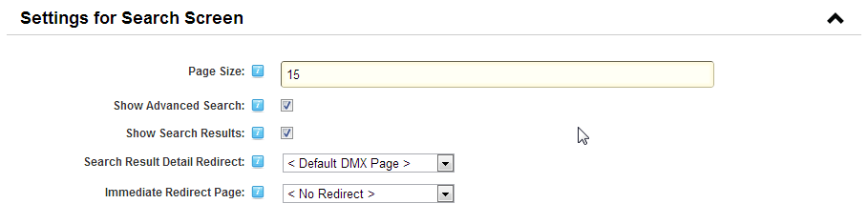
You can now stick DMX on a page and use it for the sole purpose of searching documents.

Show Advanced Search
Showing the advanced search renders a panel at the top of the screen with input for an advanced search query:
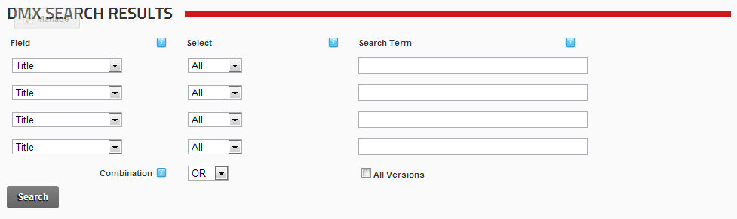
If you decide to hide it, the module will just react to the “search” querystring parameter. I.e. it will look at the querystring on the page and if there is a text after “search=” then it will use that to search DMX. Note this is the required behavior for it to be able to show DMX search results on the search results page of DotNetNuke. You can add the module to the search results page, and set it to render with search UI and to not show advanced search and you effectively have an integrated search solution in DNN.

Show Search Results and Immediate Redirect
You can use the module to just render the search input and then to hop to another page once the user clicks “Search”. The use case is if you wish to have the full Ajax UI experience for users when browsing the search results. What you do is to point the search instance of DMX to the page where you have a regular instance of DMX in Ajax UI view. Set this in the “immediate redirect” dropdown.

Search Results Detail Redirect
The search results on this page are rendered with both download and details links.
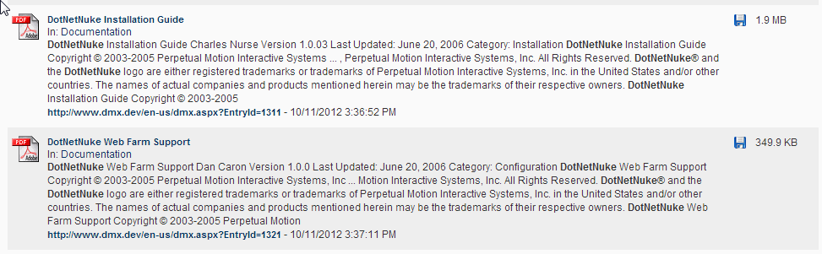
The download icon will obviously provoke a download. But the link toward the bottom should lead to a DMX instance somewhere, where the user can perform other actions on it. You can opt to send this to any page in your DNN installation. Put DMX there and it will load that document in view.

